

A Project Report on

Supplier Bid Optimization Engine

Prepare By
Suyash S. Kadu

INDEX
SR.NO | DESCRIPITION |  | PAGE NO.
1 | Project Introduction |  | 2
 | 1.1 | Project Overview | 2
 | 1.2 | The Business Context & Problem | 2
 | 1.3 | The Strategic Solution | 2
 | 1.4 | Business Value & Technical Execution | 2
2 | System & Competency Requirements |  | 3
 | 2.1 | Technical Dependencies | 3
 | 2.2 | Data Architecture & Schema Requirements | 3
 | 2.3 | Analytical & Domain Competencies | 3
3 | Objectives |  | 3
4 | Problem Statement |  | 4
5 | Technology Architecture & Tech Stack |  | 4
6 | Phase 1: Strategic Planning & Architecture Design |  | 5
7 | Phase 1: Implementation & Deployment |  | 5
8 | Phase 2: Relational Database Integration & Dynamic Visualization |  | 8
9 | Conclusion |  | 9

- Project Introduction:-

  - Project Overview
The Supplier Bid Optimization Engine (SBOE) is an enterprise-grade, Coupa-inspired strategic sourcing tool designed to evaluate raw material suppliers. The engine specifically evaluates vendors providing commodities like steel, lubricants, and bearings, and recommends the optimal way to split an order. The core philosophy driving the SBOE is that in global manufacturing, the lowest unit price is rarely the cheapest final cost.

  - The Business Context & Problem
Traditional purchasing often focuses strictly on the initial sticker price. This approach ignores critical hidden risks within the supply chain. For example, the cheapest supplier might have a 3% historical defect rate or take 45 days to deliver. These hidden variables drastically increase the final operational cost, introducing massive financial bleed that basic price comparisons fail to catch.

  - The Strategic Solution
To solve this challenge, the SBOE acts as a "financial lie-detector" for supplier bids by forcing procurement decisions to be based on Total Cost of Ownership (TCO). The mathematical engine calculates the true bottom line by explicitly penalizing vendors for hidden costs. The baseline TCO evaluation factors in:

- The initial unit price.
- Flat shipping and logistics costs.
- Historical defect rates.
- Lead times and delivery delays.

  - Business Value & Technical Execution
By shifting the focus from unit price to true bottom-line TCO, the SBOE translates complex supply chain variables into actionable financial decisions. It is specifically designed to target the needs of enterprise manufacturing companies like SKF and features high relevance to Indian manufacturing hubs like Pune and Chennai. Key capabilities include:

- Interactive Scenario Modeling: It utilizes an interactive Streamlit dashboard that empowers procurement managers to run dynamic "what-if" scenarios.
- High-Performance Processing: The logic engine is built with Python and Pandas, utilizing vectorization to ensure lightning-fast, highly scalable calculations without relying on slow for-loops.

- System & Competency Requirements:-

  - Technical Dependencies
- Proficiency in Python programming.
- Familiarity with Pandas for data manipulation and vectorization.
- Basic understanding of Streamlit for frontend UI development.

  - Data Architecture & Schema Requirements
- A structured dataset featuring realistic supplier profiles, item definitions, and historical bid metrics.
- Data structured relationally, ideal for databases like Supabase (PostgreSQL).
- Contextual data relevance to realistic manufacturing environments, such as Indian manufacturing hubs like Pune and Chennai.

  - Analytical & Domain Competencies
- A foundational understanding of supply chain metrics and strategic sourcing.
- Deep comprehension of Total Cost of Ownership (TCO) mathematical models and supply chain risk mitigation.
- The business acumen to translate complex supply chain variables into actionable financial decisions.

- Objectives:-

  - Primary Objective
To architect and deploy a scalable, interactive procurement tool that forces purchasing decisions to be based on the true bottom-line Total Cost of Ownership (TCO), rather than superficial initial unit prices.

  - Scope of Work
- Algorithmic Engine: Develop a high-performance mathematical engine using Python and Pandas to calculate TCO by penalizing vendors for hidden supply chain risks, specifically historical defect rates and lead time delays.
- Interactive Interface: Design an enterprise-grade user interface using Streamlit, styled with SKF Corporate Blue, to enable dynamic "What-If" scenario modeling for procurement managers.
- Data Architecture: Structure and manage a realistic relational dataset (simulating Indian manufacturing hubs like Pune and Chennai) containing supplier profiles, item definitions, and historical bid metrics.
- Cloud Deployment: Deploy the application to a cloud environment (e.g., Hugging Face Spaces or Render) to demonstrate production readiness and CI/CD capabilities.

  - Out of Scope
Integration with live enterprise ERP systems (like SAP or Oracle) or execution of actual financial transactions. This project serves as an analytical recommendation engine, not a purchasing execution platform.

- Problem Statement:-
- Traditional purchasing often focuses strictly on the initial sticker price. This approach ignores critical hidden risks within the supply chain.
- By evaluating bids purely on unit cost, procurement managers inadvertently introduce massive financial bleed that basic price comparisons fail to catch. For example, the cheapest supplier might have a 3% historical defect rate or take 45 days to deliver.
- These hidden variables drastically increase the final operational cost. In global manufacturing, the lowest unit price is rarely the cheapest final cost.

- Technology Architecture & Tech Stack:-

The Supplier Bid Optimization Engine (SBOE) utilizes a consolidated, Python-centric technology stack designed for rapid development and high-performance data processing.

- Coding Language: Python. The core language driving both the analytical backend and the frontend framework.

- Data Processing Engine: Pandas & NumPy. Utilized for high-performance vectorization to calculate Total Cost of Ownership (TCO) metrics across all rows simultaneously. This completely avoids slow for-loops to ensure lightning-fast execution and enterprise scalability.

- Frontend & Backend Framework: Streamlit. A unified framework that acts as both the web server and the interactive user interface. It empowers procurement managers to run dynamic "what-if" scenarios using slider inputs.

- Database Architecture: Supabase (PostgreSQL). A cloud-based relational database used to handle structured data across core tables: Suppliers, Items, and Bids.

- Cloud Deployment & CI/CD: Render / Streamlit Community Cloud. Cloud platforms utilized for live, public-facing web service deployment with continuous integration/continuous deployment capabilities directly from GitHub.

- Phase 1: Strategic Planning & Architecture Design:-

  - The Core Objective
The primary objective of Phase 1 is to establish the core mathematical backend the Pandas Optimization Engine before introducing any user interface or database connections.

  - The Strategy
The strategic goal is to build an analytical engine that acts as a financial lie-detector. It ingests raw supplier data, normalizes it, and calculates the true bottom line by explicitly penalizing vendors for hidden costs like historical defect rates and lead time delays.

  - Execution Focus
By focusing entirely on the Python logic first, the business logic remains successfully decoupled from the eventual Streamlit UI. This ensures that the engine is highly scalable and can be tested locally using a mocked CSV dataset (e.g., a scenario of 5 suppliers bidding on 10,000 bearings).

- Phase 1: Implementation & Deployment:-
Phase 1 executes the core analytical engine in Python. It involves breaking down the execution into sub-steps, from establishing the mathematical formula to testing locally and deploying to the cloud.

  - Core Business Logic & Algorithmic Ruleset
The engine normalizes data, so every supplier is judged on the exact same criteria. It calculates the true bottom line by factoring in unit price, shipping costs, historical defect rates, and lead times.

  - Total Cost of Ownership (TCO) Mathematical Model
The baseline TCO evaluation takes the unit price and stacks financial "penalties" on top of it. The exact formula implemented is:
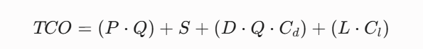

  - Data Ingestion & Relational Structuring

For Phase 1, the data is consolidated into a single, comprehensive flat table (CSV) to streamline ingestion into the Pandas optimization engine. Rather than using multiple relational tables, this unified dataset encompasses all requisite variables in one place. It seamlessly combines overarching supplier profiles (e.g., Reliability Score, Region, Max Capacity), item definitions (e.g., Baseline Cost, SKU, Commodity), and the dynamic transactional bid inputs (e.g., Unit Price, Lead Time, Defect Rate) required for the algorithm.
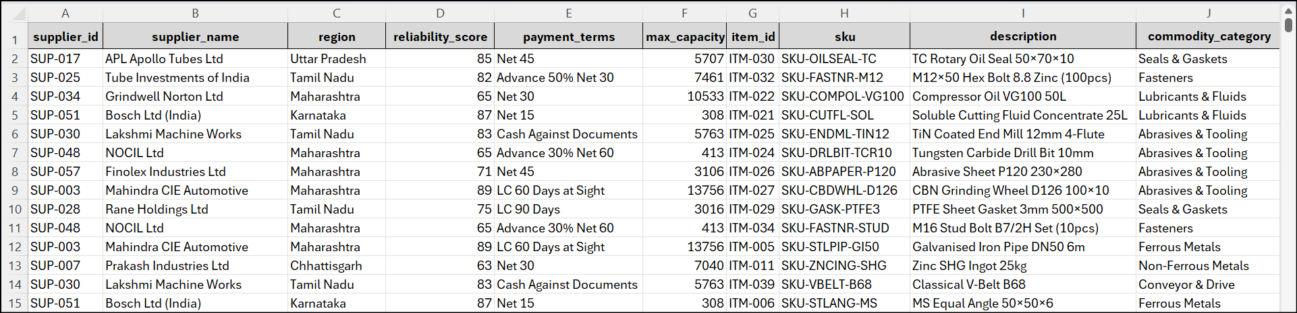

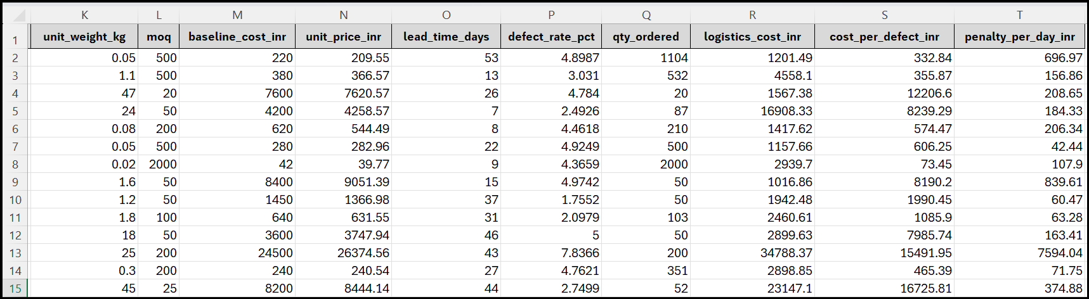

  - Initial Research & Development (R&D) via Vectorized Operations

Initial R&D was conducted in a Jupyter Notebook to test the math without UI overhead. To ensure lightning-fast execution and enterprise scalability, Pandas vectorization was utilized to calculate metrics across all rows simultaneously, avoiding slow for-loops entirely.
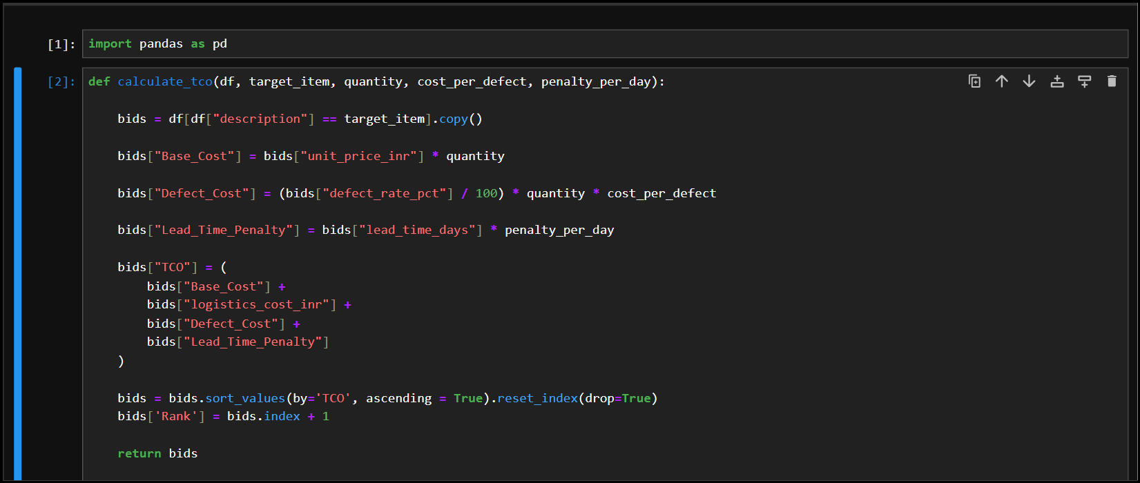

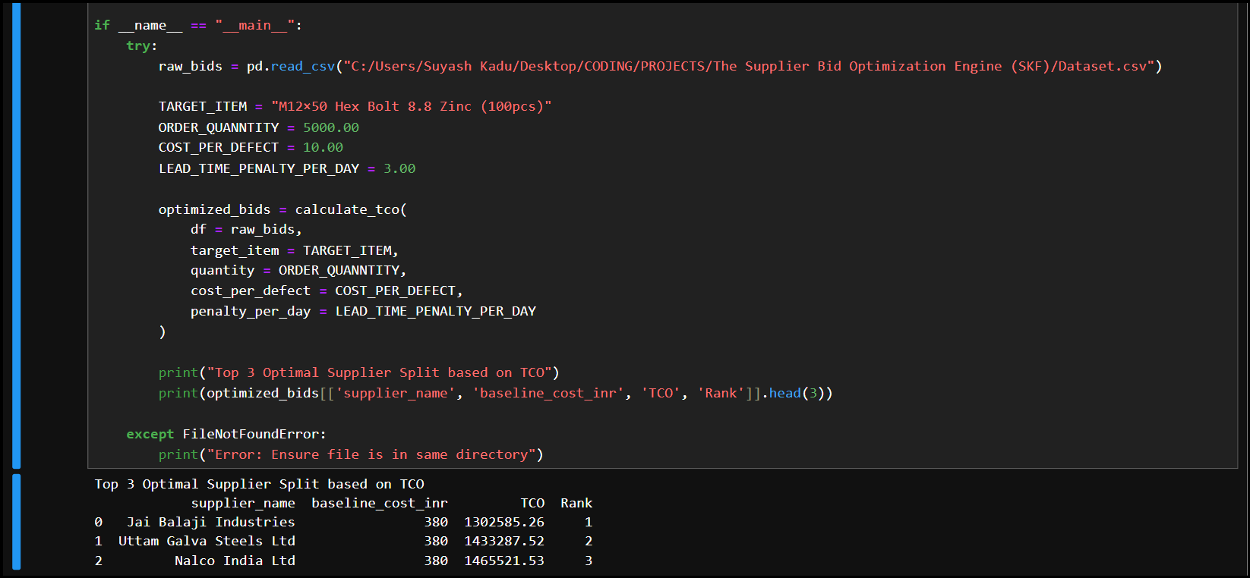

  - Data Validation & Algorithmic Testing

The decoupled architecture allowed for rigorous testing using a mocked CSV dataset of suppliers bidding on industrial materials like bearings.
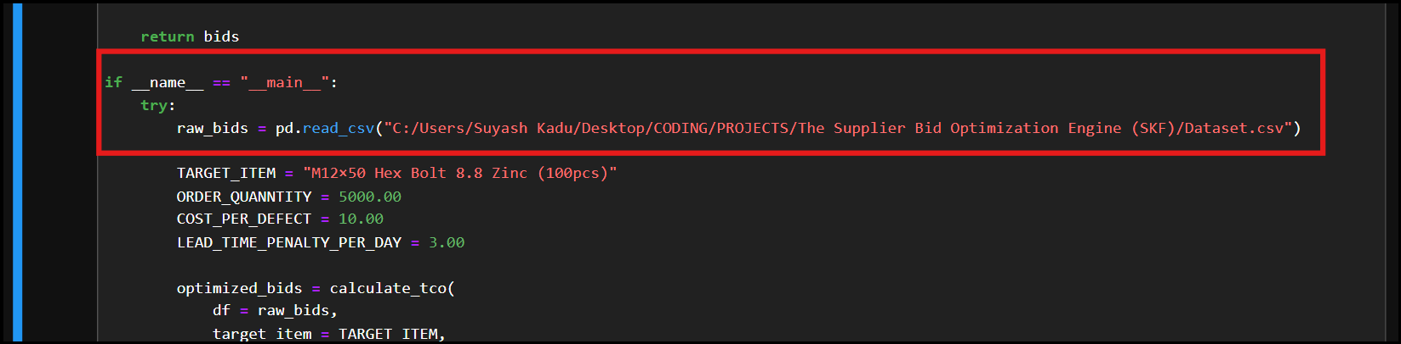

  - Enterprise Codebase Transition

The raw Python logic (specifically the calculate_tco() function) was transitioned into an app.py script in VS Code, officially separating the analytical math from the frontend.

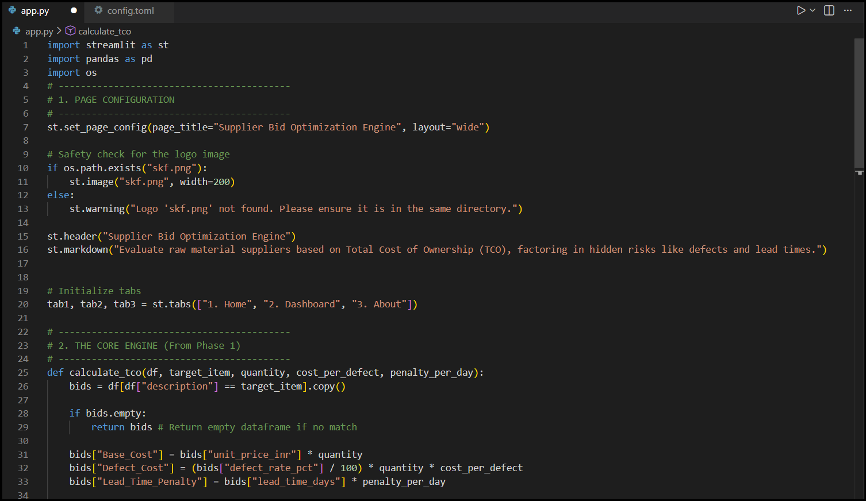

  - Interactive User Interface (UI) Architecture

The logic was wrapped in an interactive Streamlit dashboard featuring an SKF Corporate Blue theme. The interface empowers procurement managers to run dynamic "what-if" scenarios using sidebar slider inputs.

  - Local Environment Testing & UI Refinement

The Streamlit UI was tested on localhost using the command streamlit run app.py via the VS Code terminal.

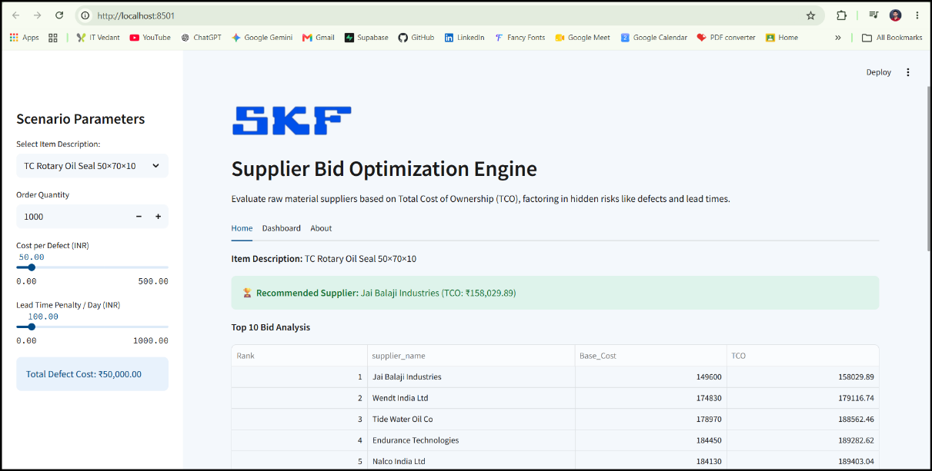

  - Cloud Deployment & CI/CD Integration

The final step of Phase 1 involves deploying the application to a cloud environment (such as Render or Streamlit Community Cloud) to demonstrate production readiness and establish a continuous integration/continuous deployment (CI/CD) pipeline.

(Web Link - https://skf-supplier-bid-optimization-engine.onrender.com)

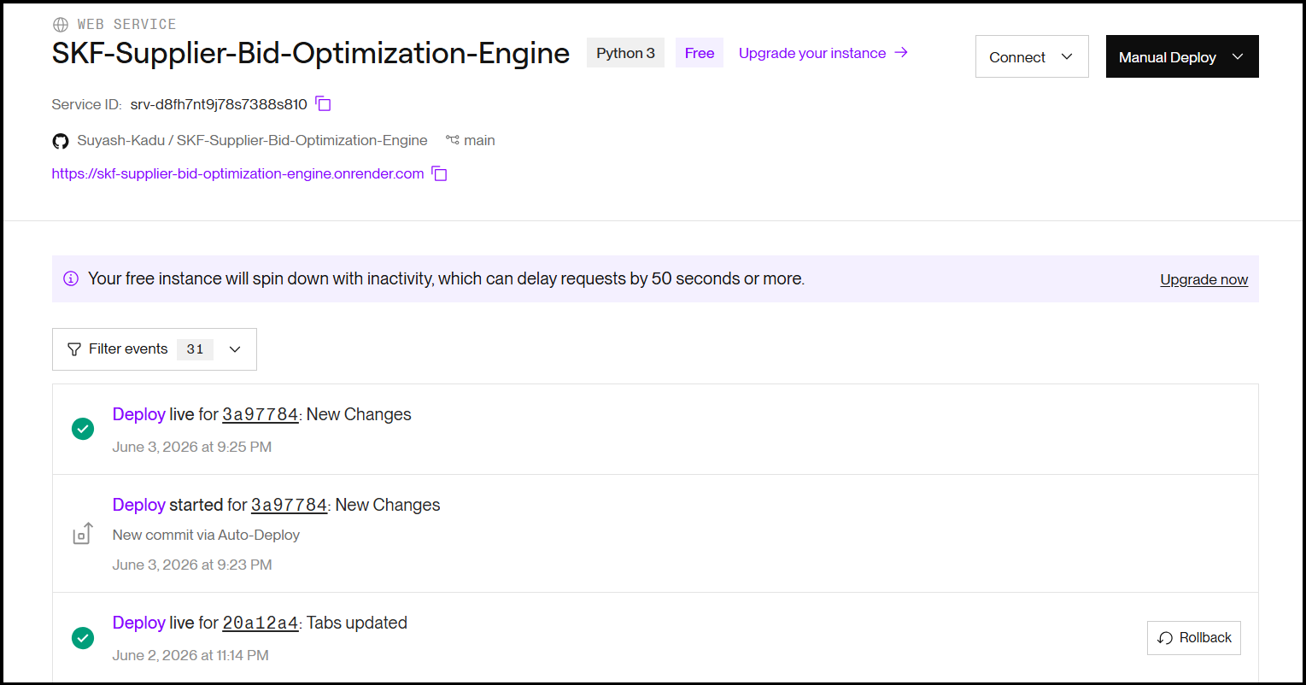

- Phase 2: Relational Database Integration & Dynamic Visualization:-

Phase 2 elevates the application from a static prototype to a production-ready enterprise tool by replacing the mocked CSV files with a live, relational database architecture.

  - Database Integration
The static data structure will be migrated to Supabase (PostgreSQL). By integrating the Supabase Python client, the app will securely pull live, relational supplier data directly from the cloud database.

  - Caching Strategy
To maintain the lightning-fast performance established in Phase 1, Streamlit's caching mechanisms (@st.cache_data) will be heavily utilized. This prevents redundant database queries, ensuring the app doesn't refresh data every time a procurement manager adjusts a 'What-If' slider.

  - Dynamic Dashboarding
The Streamlit UI will be expanded into a dynamic dashboard, styled with the SKF Corporate Blue theme. It will feature dropdowns for multi-RFP filtering (e.g., dynamically filtering out irrelevant suppliers when comparing steel vs. lubricants) and interactive visualizations to compare the Base Cost versus the true bottom-line TCO.

- Conclusion:-

The Supplier Bid Optimization Engine (SBOE) successfully translates complex supply chain variables into actionable financial decisions.

By establishing a robust mathematical backend that forces purchasing decisions to be based on Total Cost of Ownership (TCO), the tool acts as a financial lie detector for supplier bids. It proves that in global manufacturing, the lowest unit price is rarely the cheapest final cost.

Leveraging modern Python data structures (Pandas vectorization) and interactive web frameworks (Streamlit), the application provides a scalable, enterprise-grade solution. It empowers procurement managers to run dynamic "what-if" scenarios , ultimately protecting multi-million dollar manufacturing contracts from hidden financial bleed.

